ITP4506 Human Computer Interaction & GUI Programming

Assignment

Web design analysis and user analysis

|  |  |  |  |
| --- | --- | --- | --- |
| Student ID | Name | Contribution | Signature |
| 160039700 | CHEUNG Pui Lam | 50% |  |
| 160158135 | LAM Ho Yin | 50% |  |

Table of Contents

1 User Analysis 3

1.1 User Characteristics 3

1.2 Techniques for observing and listening to users 4

1.3 Environment Analysis 4

1.4 Recruiting Users 4

1.5 Task Analysis (HTA) 5

2 Web Design 7

2.1 Mental Model 7

2.2 Affordance 18

2.3 Content Organization 22

2.4 Visual Organization 23

2.5 Navigation 26

# User Analysis

|  |
| --- |
| Target Users |
| Tertiary students in Hong Kong |

## User Characteristics

1. Learning style

Do-then-read

Tertiary students in Hong Kong can access to internet easily, they are experience in browsing different website. While browsing a website the first time the targeted user will not try to find a user guide to learn how perform different task with the website. The user group are willing to take the risk, they prefer using a system without reading the user guide. From the behavior above the user group learning style can be consider as “Do- then-read”. While designing the interface for the website, the UI should allow the user to recognize command on a menu.

1. Tool preferences

Mouse or keyboard

As the project will only be desktop compatible, it is assumed that the user will use a PC desktop. For desktop input tools, the user group are experienced in using mouse and keyboard as input tools.

1. Physical differences

Good visual abilities

Tertiary students in Hong Kong are young adult. According to University Grants Committee Customised Data Retrieval, in academic year 2015/2016 their students are aged widely, most of them are aged at from 19 to 22 years old.[1] It is believed that the people in this age are having good muscle strength and less visual difficulties. Although most of the user do not have physical problems, but there is user in this age range suffering from physical disabilities and visual disabilities, they might have problem with controlling mouse and keyboard or color-blindness.

1. Cultural differences

High education background

Tertiary students in Hong Kong study in different university and institution learning professional knowledge.

Can read Chinese and English

Tertiary students in Hong Kong included locals and non-locals, most of them can read English.

1. Knowledge of job

Familiar with online purchasing or booking

The target user can perform the job in anywhere as they have a laptop or a pc desktop on hand. The job of purchasing travel package and booking hotel can be easily understand, user do not need to learn what is purchasing or booking. User will understand what the website functions is.

1. Application familiarity

Either novice or expert

User can be either novice or expert to online sales system. As many platforms provide online purchase or booking, user may have the experience in using this kind of application, they can understand the flow of the job and have the knowledge on diagnosing problems during perform the job. On the other hand, user may only have the concept of online purchasing or booking, they might not have performed the job before. From this discovery the website interface design should similar the other online purchase or booking website, so user can recognize flow of the services.

## Techniques for observing and listening to users

Online surveys

As the services is web-based online system, user can do a survey after they use the system, this way the project team can obtain review from different users to improve the website.

## Environment Analysis

On computer

The target users can easily access to PC desktop or laptop.

## Recruiting Users

Test with real current users (Customers)

Customers will be recruited to test the website usability and function, their comment are important to the website development. With customers help the project team can easily how quick the user can learn to user the interface. In additions, users help can ensure the website design are following the “recognize” principal.

## Task Analysis (HTA)

* Main Task
* Register
* Login
* Search Product
* Make Booking
* Make Payment
* Make Review
* Register

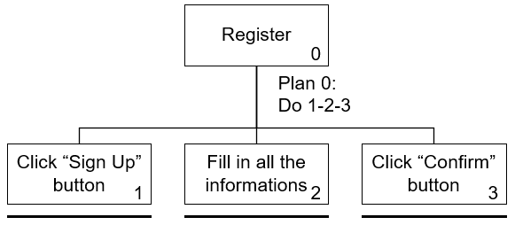

* Login

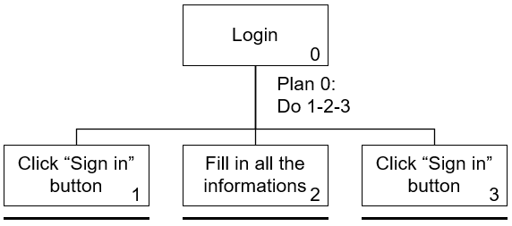

* Search Product

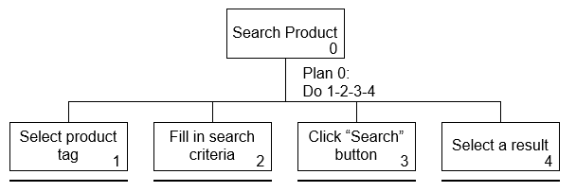

* Make Booking

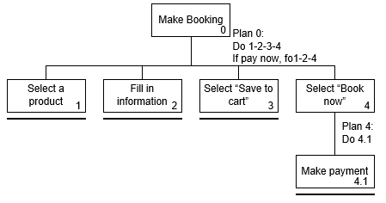

* Make Payment

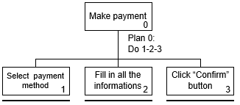

* Make Review

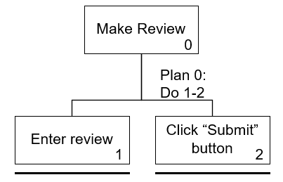

# Web Design

## Mental Model

* Register

|  |  |
| --- | --- |
| Mental Model |  |
| For register mental model <http://www.hongthai.com> register flow is referenced. This register flow design is a commonly used by differnet website, it is simple and clear, it is expected that the target user have this as mental model. | |
| 1. click “register” 2. enter the information required 3. click “submit” |  |

|  |  |
| --- | --- |
| Current Design |  |
| In order to let user to find the “Sign up” button, the button is placed the navgation bar, this is a commanly used design. After user click the “Sign up” button they are directed to the sign up page. The register process require user to input many data, in order to let user fell the register process is fast and easy, the sign up page is devided into 3 parts. First, user input the account information. Then, the personal information. Finally, they can review the informatiom inputed and agree the trem and condition. They can click comfirm to finish the registration process. | |
| 1. click “register” 2. enter the account information 3. click “Next” 4. enter the personal information 5. click “Next” 6. confirm information and agree terms and conditions 7. click “Confirm” |  |

Login

|  |  |
| --- | --- |
| Mental Model |  |
| For login mental model https://www.hotelscombined.hk/ login flow is referenced. HotelsCombined used a pop up box as the login interface, by using this method user can login faster without directing to another page. This is commonly be adopt to different websites like Twitch and TripAdvistor | |
| 1. click “login” 2. enter the information required 3. click submit |  |

|  |  |
| --- | --- |
| Current Design |  |
| In order to let user to find the “Sign in” button, the button is placed the navgation bar. After user click the “Sign in” button a pop up box is showed.  User can input their username and password to sign in, this is a design commonly seen for sign in function. User can click the blured area or click cancel to close the box. | |
| 1. click “Sign in” 2. enter the account information 3. click “Sign in” |  |

* Search Product

|  |  |
| --- | --- |
| Mental Model |  |
| For search product mental model different booking website are referenced. The design of putting the search box in the banner session of the website is very commonly used amoung booking website. User can enter a distination, check in/out or date etc. to search for items. It is believed that the design can help start searching for product as soon as the website is loaded. The user will be direct to the result page to view products. | |
| 1. enter the information required 2. click “Search” |  |

|  |  |
| --- | --- |
| Current Design |  |
| By adoping search product mental model, a search interface is inlcuded in the banner of the index, this is convenient design for user, they can search for product dirrectly after the index page is loaded. User will then be directed to the result page, user can see a simular search box in the banner, user can serach for different product is result page directly. | |
| 1. Select “Tour” or “Hotels” 2. enter the search requirements 3. click “Quick Search” |  |

* Make Booking

|  |  |
| --- | --- |
| Mental Model |  |
| For make booking mental model different booking website are referenced. After user be directed to the deatail page of a product, user can see a book now button, the screen will smooth scroll to the booking session where user select the date of reservation and the room type. Most of the booking website will then direct user to the payment page. | |
| 1. Click “Book now” 2. Enter select date and room type 3. Enter payment information |  |

|  |  |
| --- | --- |
| Current Design |  |
| Referencing make booking mental model, in the deatail page of product a “Book now” button is provided, user can click the button and select date and room type. Under the request of Happy Travel it is the best to provide a option to user, selecting “pay now” or “add to cart”, so that user can pay immediately or pay later. | |
| 1. Click “Select” 2. Enter select date and room type 3. Select “pay now” or “add to cart” |  |

* Make Payment

|  |  |
| --- | --- |
| Mental Model |  |
| For make payment mental model different booking website are referenced. Usually user are required to enter their name and contact information, after they need enter the payment information like credit card number and security code. | |
| 1. Enter personal information 2. Enter payment information 3. Click “confirm” |  |

|  |  |
| --- | --- |
| Current Design |  |
| The mental model will be referenced, user can pay directly or pay later. User can pay for all the items in the “My cart” page. User will then be ask to enter their name and contact, also as payment information. | |
| 1. Click “Pay now” 2. Enter information 3. Click “Confirm” |  |

* Make review

|  |  |
| --- | --- |
| Mental Model |  |
| For make payment mental model different booking website are referenced. Usually In TripAdvistor a button “Write a Review”, giving rate and review. | |
| 1. Click “Write a review” 2. Enter review 3. Click “submit” |  |

|  |  |
| --- | --- |
| Current Design |  |
| To let user make review easily a comment session will be put at the deatail page of each product item. The mental model of user is considered, user can enter rating and comment while making comment. | |
| 1. Enter information 2. Click “Submit” |  |

## Affordance

|  |  |
| --- | --- |
| Physical Affordance |  |
| Search box  The search box is blatant and clear, located in the banner of the index. The appearance instantly clear to a user that they can search product from this session. | |
| Top hotels session  The arrow icon in the left and right is a button that allow user to view more hotels. The design is straightforward of affordances. | |
| Search result page  The page is divided in to left and right side, it clear that the user can sort the result using the left panel. Anyone would be able to guess what action they can perform just by looking at this affordance. | |
| Button  All call to action button is similar to search another, featuring a consistent design. The button is using a rounded corner and the color will slight change while on hover, this way the button can seems clickable to user, ensuring that they know it is a button. | |

|  |  |
| --- | --- |
| Language Affordance |  |
| Result page sorting panel  A language affordance is applied in here. “Search hotel by name” and “Filter hotels by” is indicated, so that user will have no room to the imagination as to what the intended action is. In this case, user can find very clear that they can sort hotel by their name or checking the box of criteria the sort hotels. | |

|  |  |
| --- | --- |
| Iconic Affordance |  |
| Icon  The search button is using magnifying glass symbol to tell it action is related to search. Stars icon is used to present to hotels star rating, user can select the stars of hotel they want. The amenity of hotels is shown along with different icon, so that user can get the information quicker. | |

## Content Organization

|  |  |
| --- | --- |
| Alphabetical Organizational |  |
| Select destination  The Countries name is sorted by alphabetical, along with different cities of the country. User can select easily. | |

|  |  |
| --- | --- |
| Chronological Organizational |  |
| Price sorting  The price sorting in the result page is using chronological organizational. It is easier for user select a price range. | |

## Visual Organization

|  |  |
| --- | --- |
| Alignment |  |
| Vertical-align  Vertical-align is used to align the review, all review is aligned properly, so that the presentation can be more clear and consistent.  Horizontal-align  In the website horizontal-align is used to align the information and control. | |

|  |  |
| --- | --- |
| Consistency |  |
| Result list  The result list item in the result page is consistency to each another, user can recall what information is located quickly. This also present a clean and consistent design.      Payment Gateway  The payment options is contained by a card, payment option is listed consistently, user can imagine that this is two different payment options. | |

|  |  |
| --- | --- |
| Contrast |  |
| Text Content  The text content of this website is using white as background and black as font-color, the contrast is enough, allowing user to read comfortably. | |

## Navigation

|  |  |
| --- | --- |
| Navigation |  |
| Breadcrumbs  Breadcrumbs is used to show the user currently where they are, so they will not fell lost while browsing the website. | |
| Global Navigation  Using global navigation keep the website navigation simple and clear, user can clearly know what navigation to click to perform specific task. Together with the Breadcrumbs, the user experience can be farther enhanced, user will never get while using the website. | |

1. University Grants Committee Customised Data Retrieval. (2016). [online] Available at: https://cdcf.ugc.edu.hk/cdcf/indepthAnalysis.do [Accessed 29 Nov. 2017].